SCREENSHOT 1: Compilation
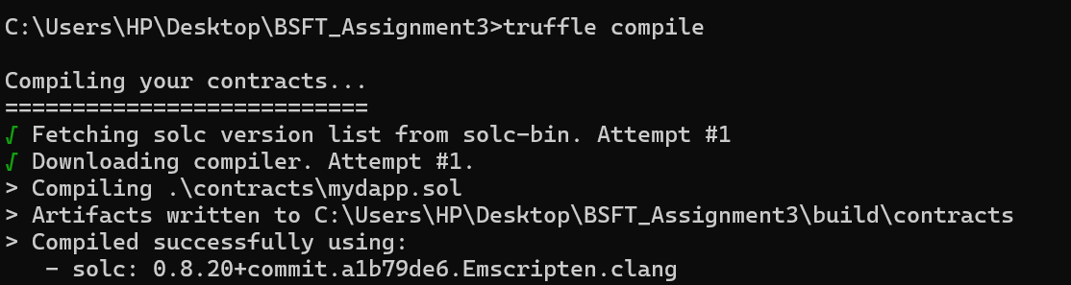
SCREENSHOT 2: Migration
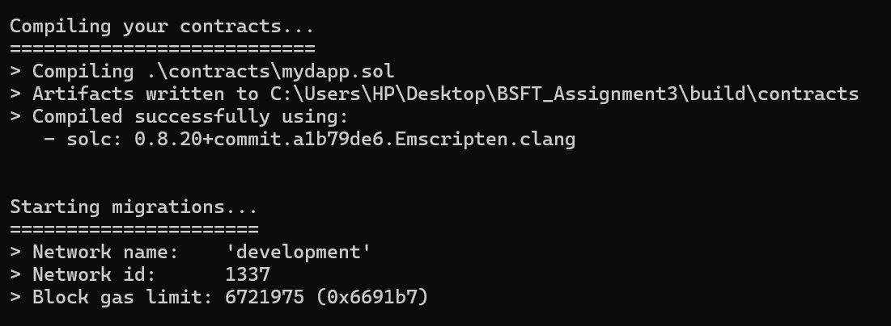
SCREENSHOT 3: Deployment

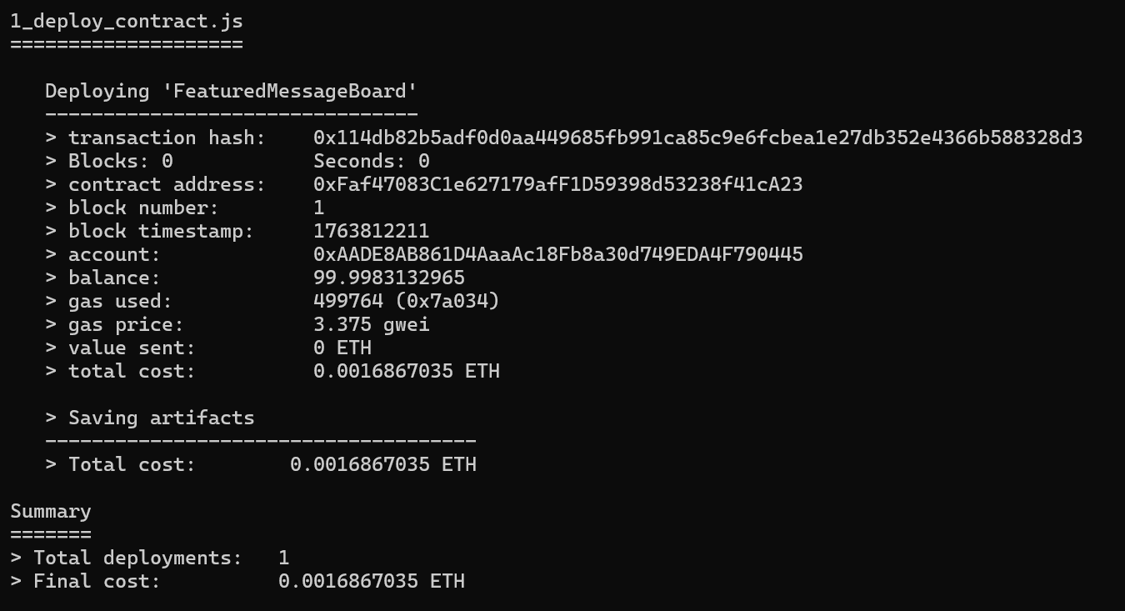

SCREENSHOT 4: Tx on Ganache
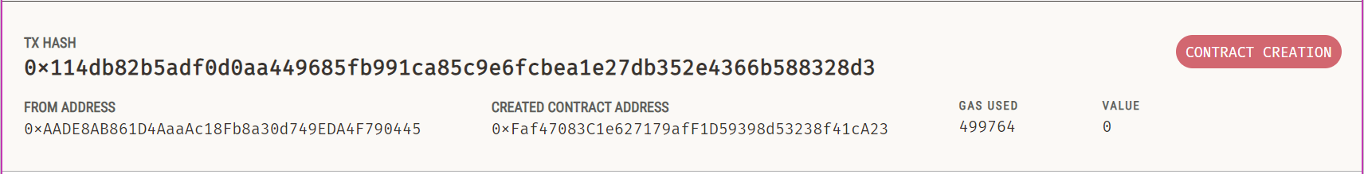

SCREENSHOT 5: TESTING FOR CONNECTION:
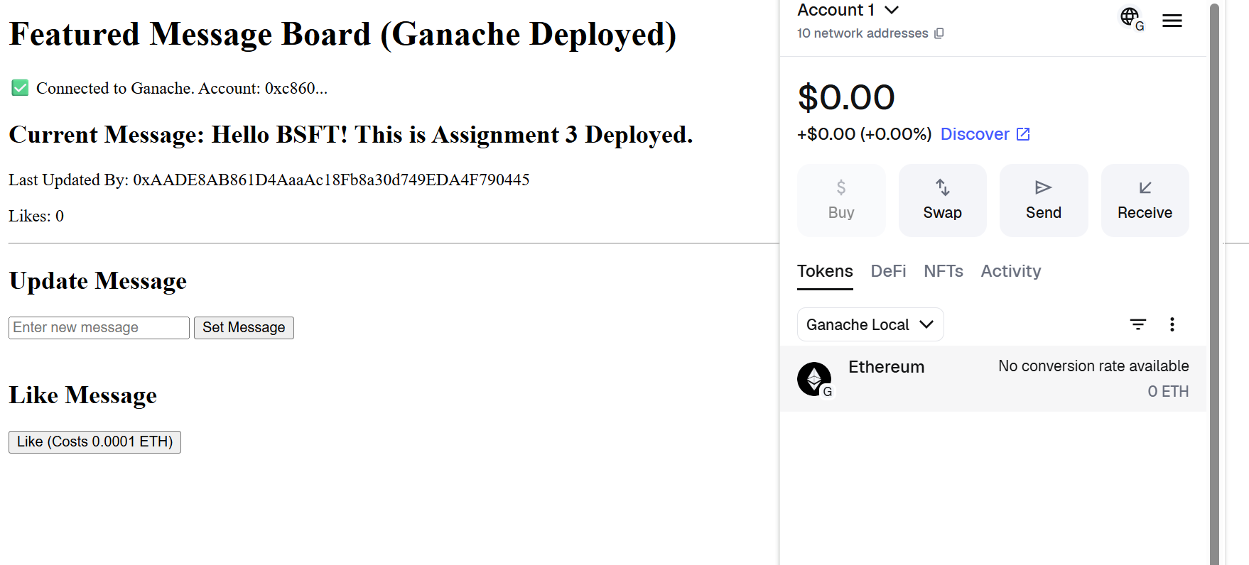
SCREENSHOT 6: TEST INTERACTION
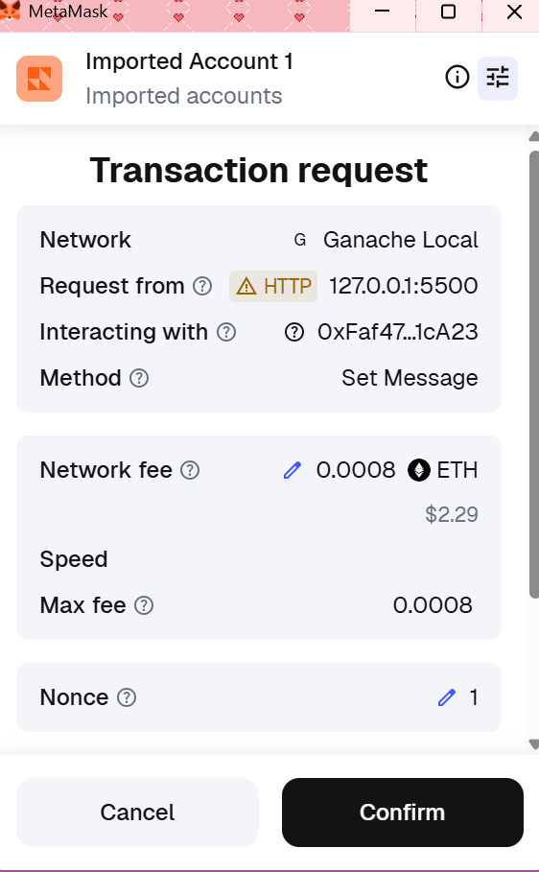

SCREENSHOT 7: Test Message Updated
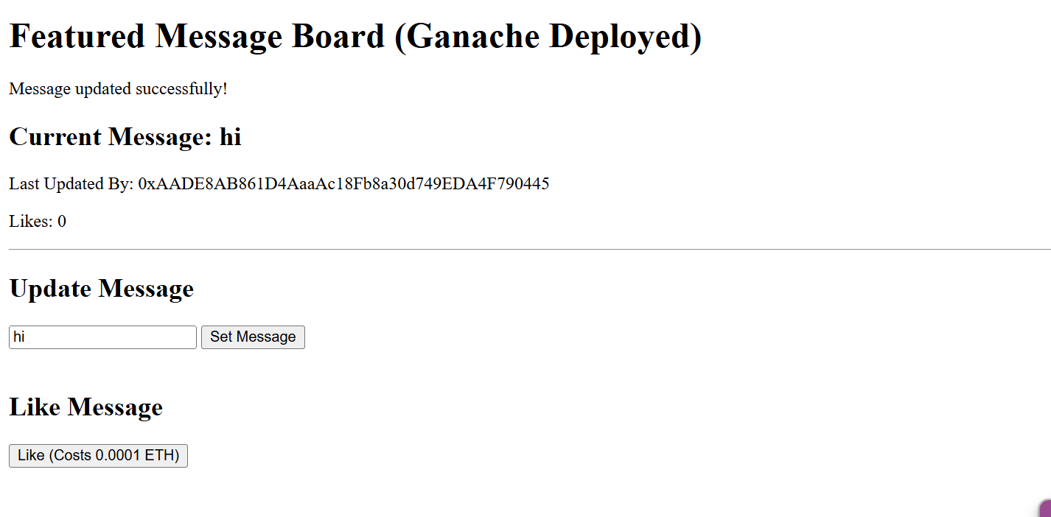
SCREENSHOT 8: UPDATED UI
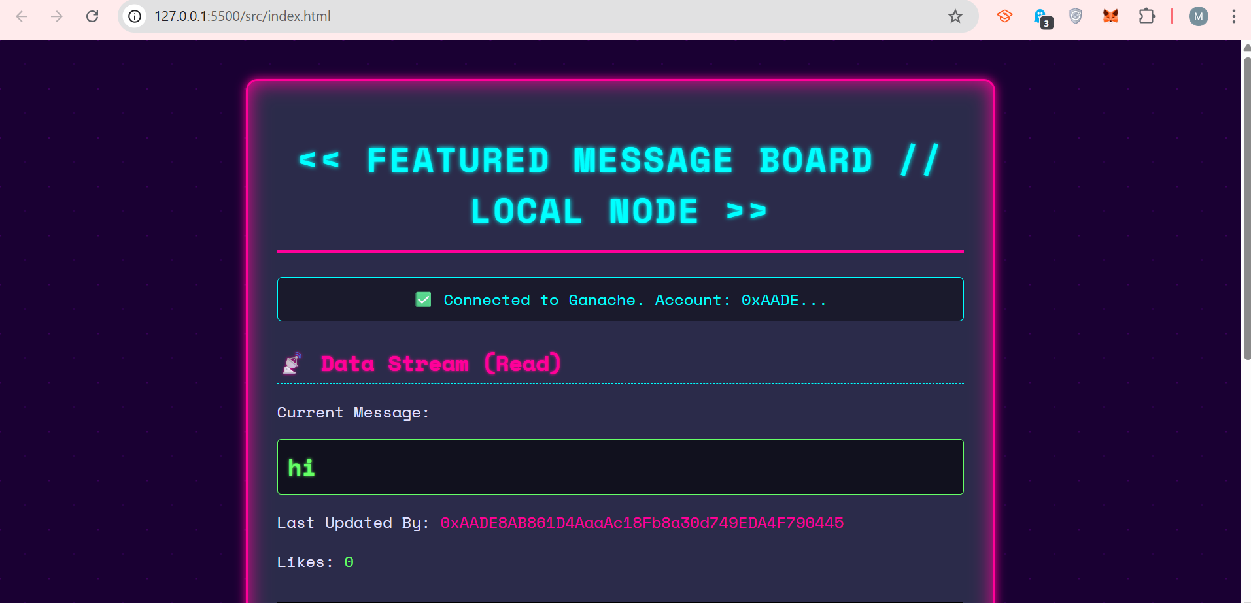

SCREENSHOT 9: UPDATED UI (2)

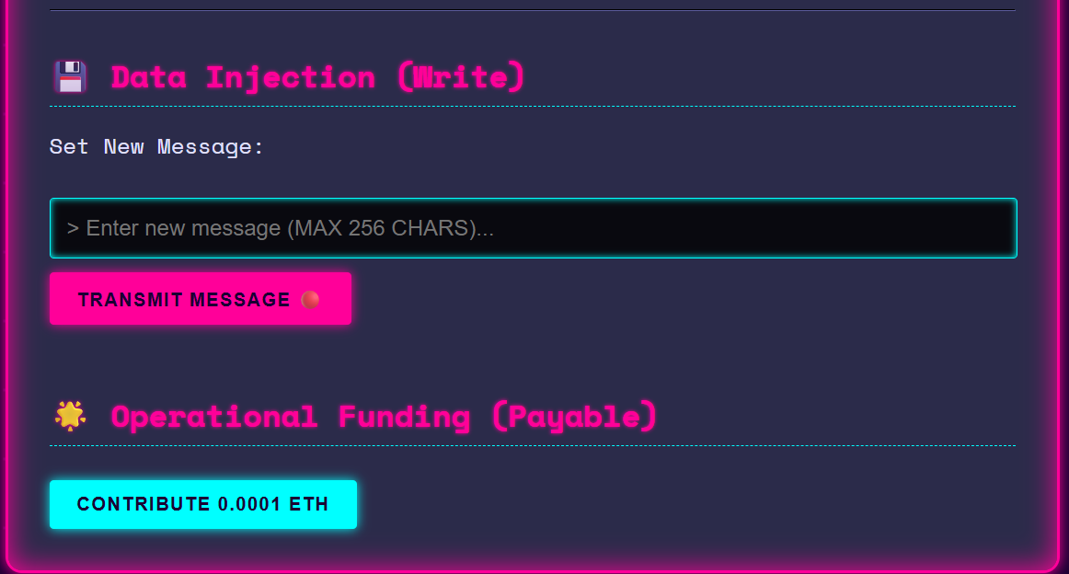
SCREENSHOT 10: UPDATED UI 1ST INTERACTION (SEND MESSAGE)
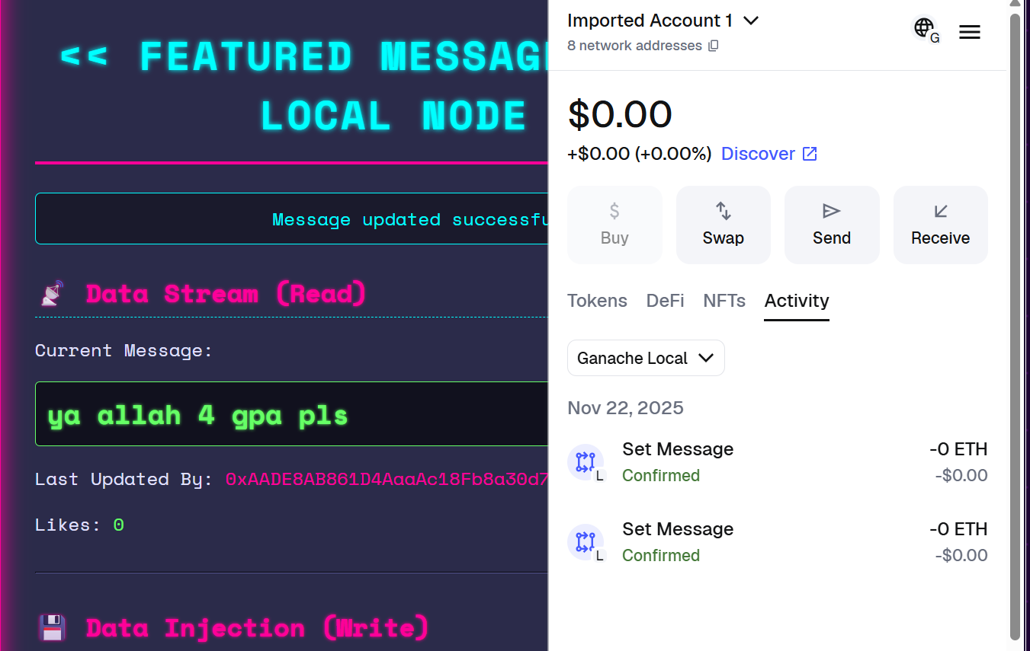

SCREENSHOT 11: UPDATED UI 2ND INTERACTION (LIKE MESSAGE)
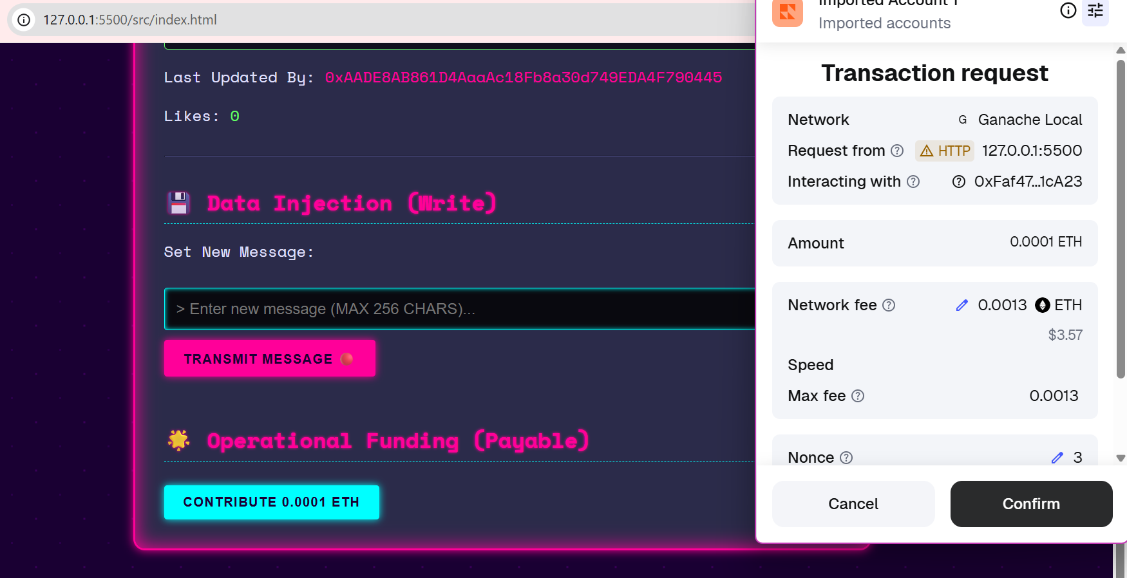
SCREENSHOT 12: UPDATED UI LIKE RECORD
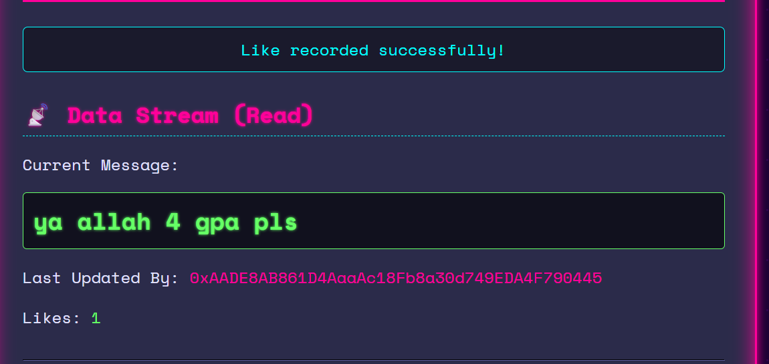

SCREENSHOT 13: UPDATED UI 3RD INTERACTION (SEND NEW MESSAGE)
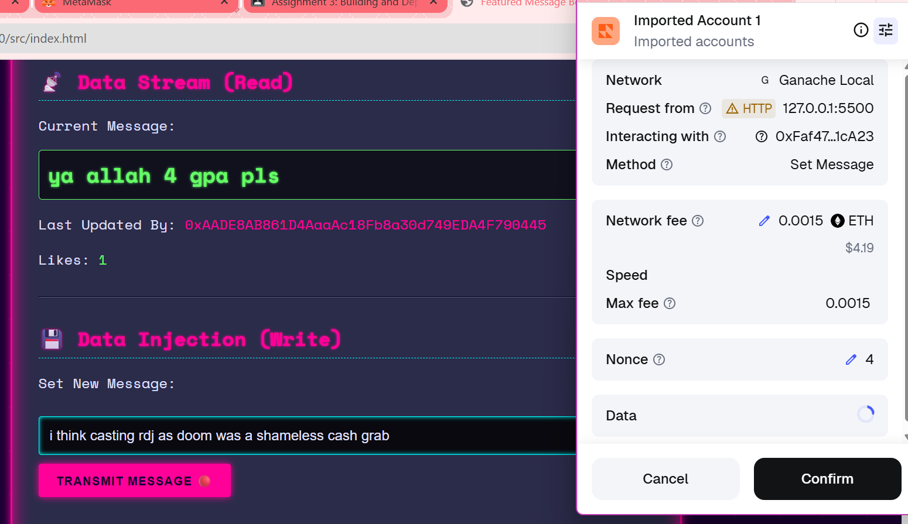
SCREENSHOT 14: UPDATED MESSAGE RECORD
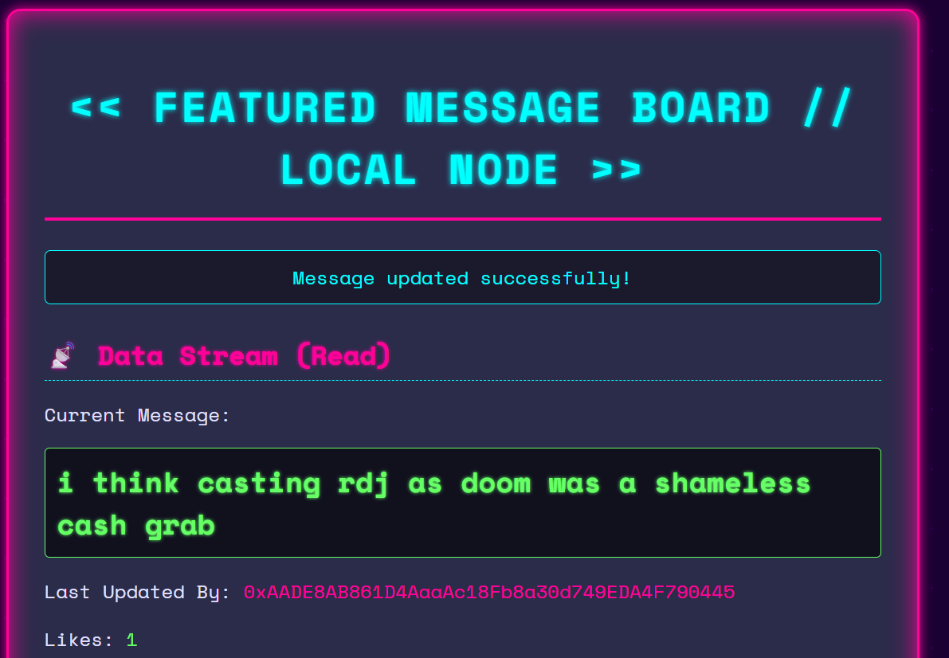
SCREENSHOT 15: UPDATED UI 4TH INTERACTION (LIKE MESSAGE)
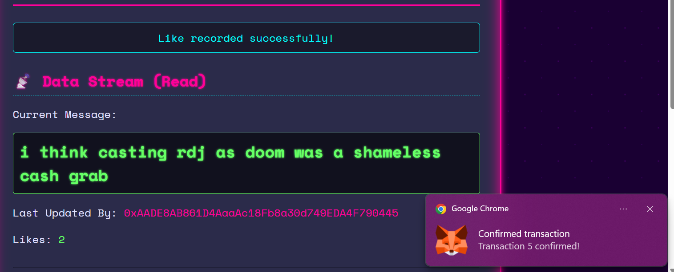
SCREENSHOT 16: ALL METAMASK TRANSACTIONS
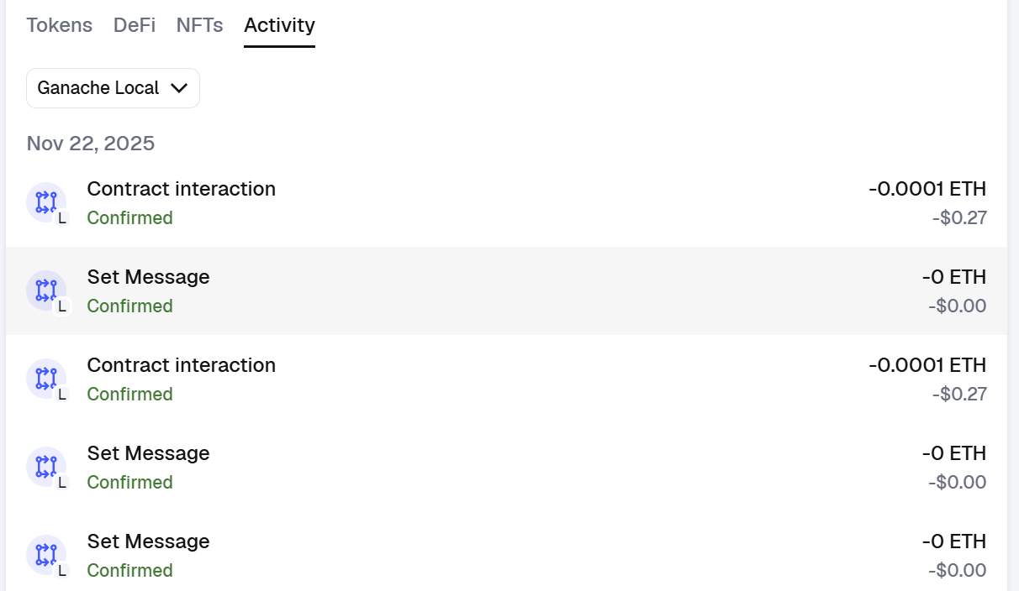

SCREENSHOT 17: ALL GANACHE TRANSACTIONS

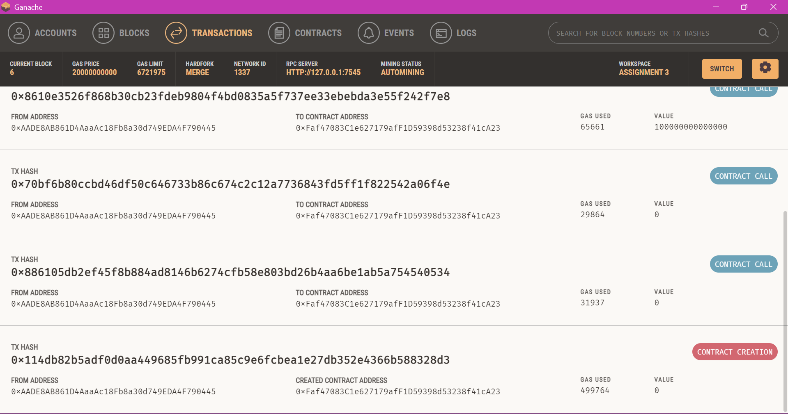
SCREENSHOT 18: ALL GANACHE TRANSACTIONS (2)
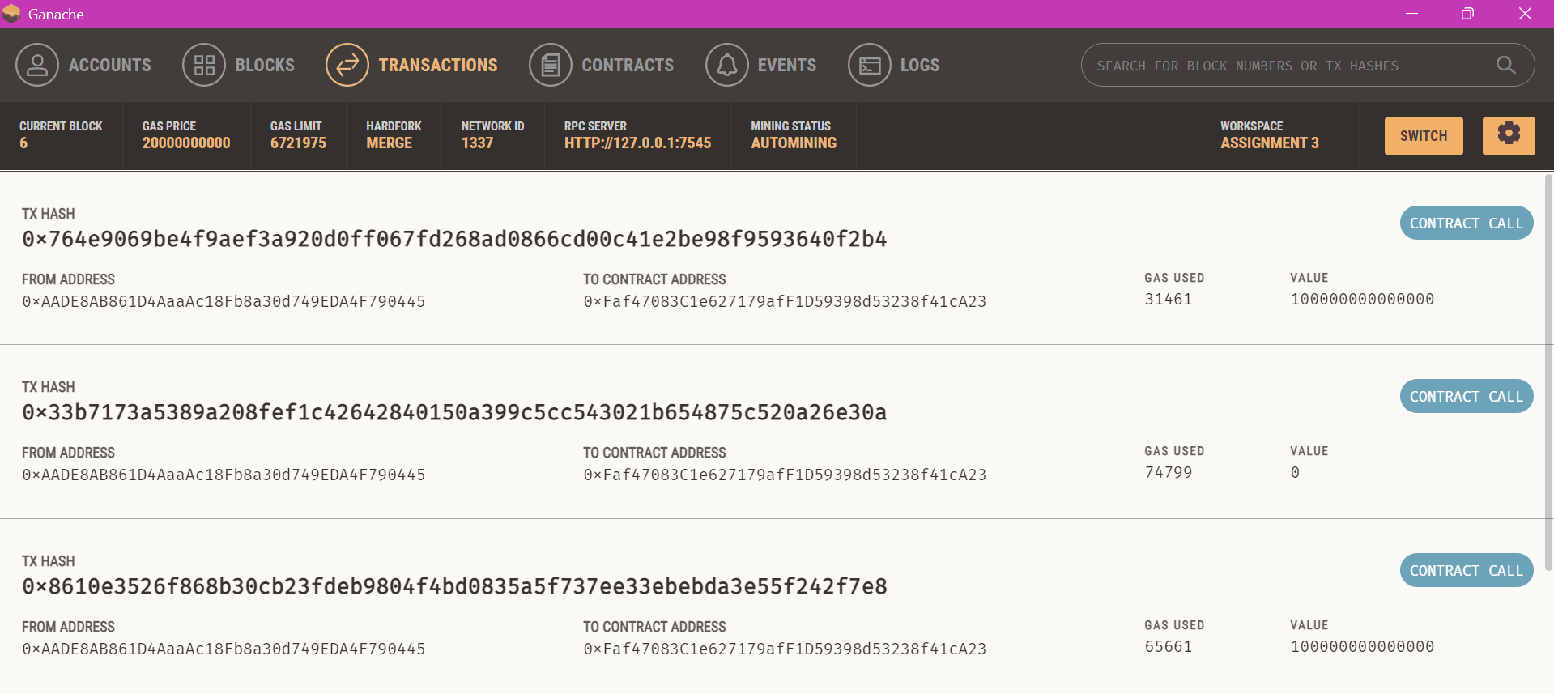

SCREENSHOT 19: ALL GANACHE TRANSACTIONS BLOCKS

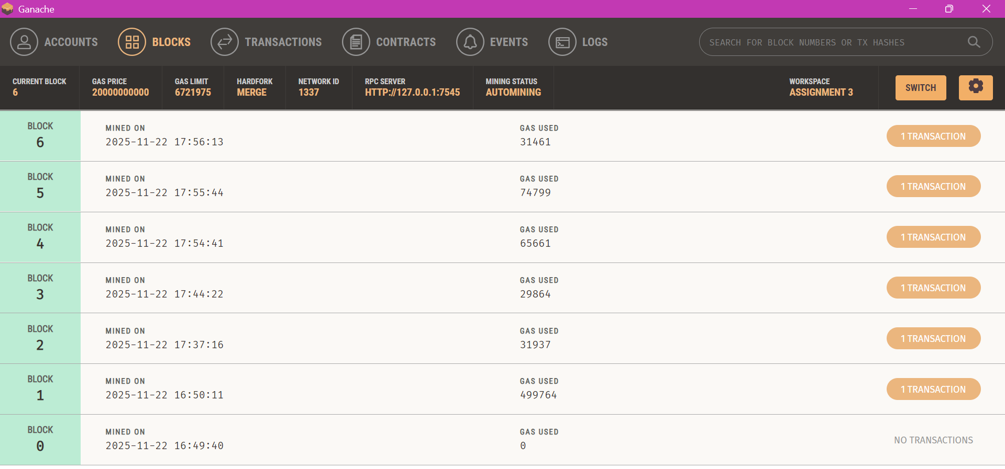
SCREENSHOT 19: GANACHE ACCOUNT OVERVIEW

